Major Project Synopsis Report
SMART SCAN
Project Category: Start-up Based Project
Projexa Team Id- 26E4058

Submitted in partial fulfilment of the requirement of the degree of
BACHELOR OF COMPUTER APPLICATIONS
in
AI & DS (Section -B)
to
K.R Mangalam University
by

AARYAT KHATRI (2301201112)

Under the supervision of

Ms. Vandna Batra

Department of Computer Science and Engineering School of Engineering and Technology
K.R Mangalam University, Gurugram- 122001, India January 2026

INDEX

1. | Abstract | 3
2. | Introduction (description of broad topic) | 4
3. | Motivation | 5
4. | Literature Review | 6
5. | Gap Analysis | 7
6. | Problem Statement | 8
7. | Objectives | 9
8. | Tools/platform Used | 10
9. | Methodology | 11
10. | References | 12

ABSTRACT

Smart Scan is a digital receipt management system created with the aim of helping people maintain their financial receipts in a neat, secure, and organized manner. In everyday life, we constantly make purchases—whether it’s from a supermarket, a pharmacy, a restaurant, an online store, or during travel. Each of these transactions generates a receipt that can become important later on. These receipts might be required for returns, warranty claims, reimbursements, tax purposes, or simply for tracking how much a person spends in a month.

However, most of the time, people either throw receipts into bags or drawers or leave them mixed within emails and downloads. Eventually, when a receipt is needed, it becomes extremely difficult to find, and in many cases, it may already be lost or damaged. This is a common and frustrating problem for students, professionals, business owners, freelancers, and almost every individual who makes regular financial transactions.

Smart Scan attempts to solve this everyday problem by allowing users to upload receipts easily using photos or digital files. Once uploaded, the system extracts important details from the receipt, such as the date, merchant name, tax amount, total cost, and any other clearly visible key information. These details are then saved digitally in a proper, structured format, keeping records clean and easy to navigate. One of the main benefits is that users no longer need to worry about keeping physical receipts safe. Digital storage ensures that receipts do not fade, tear, or get misplaced. Everything remains accessible in one organized place whenever the user needs it.

Another key aspect of Smart Scan is its ability to categorize receipts automatically. It groups expenses into categories like food, groceries, travel, utilities, health, shopping, and more. This helps users understand their spending patterns more clearly. Instead of going through dozens of paper receipts, users can simply filter their records based on category or date. This makes budgeting easier and helps users become more aware of their financial habits. Smart Scan also reduces paper usage and supports a more eco-friendly way of managing documents, something that is becoming increasingly important in today’s digital age.

INTRODUCTION

Managing receipts is something most people have to deal with regularly, but very few actually organize them properly. Whether the receipt comes from a shop, a restaurant, a medical store, an online purchase, or a travel booking, it is always meant to serve as proof of a transaction. These receipts contain important information like the date, amount paid, items purchased, and merchant details. Although they look small and insignificant at first, they become important whenever someone needs to track their expenses, return a product, check a warranty period, or claim reimbursement from a company or institution. The problem starts when these receipts begin piling up and eventually get lost, torn, faded, or buried under other papers.

Today, most people have mixed types of receipts—some in paper form and others in digital form. But even digital receipts are not easy to manage because they get scattered across apps, emails, screenshots, downloads, and phone galleries. When someone needs to look for a specific receipt after weeks or months, they end up wasting a lot of time searching across different folders or piles of papers. This leads to frustration and poor financial record-keeping. Many people want to track their expenses, but the process becomes so tiring that they simply avoid it.
Smart Scan is introduced as a simple and helpful way to deal with this everyday problem. The idea is to make receipt management less stressful by storing everything digitally in one place. Instead of keeping paper receipts safe or worrying about losing them, a person can simply take a photo of the receipt or upload a file and let the system save it. Once saved, the receipt is not just an image sitting in the system; its important details are also identified and stored in an organized format. This makes future searching much easier because users can filter their receipts by date, category, merchant, or amount.

Smart Scan also supports category-wise storage, which helps users understand where they spend the most—whether on food, travel, shopping, utilities, or other areas. This small feature can help users plan their monthly budgets better and develop healthier spending habits. The whole idea of Smart Scan is to make financial organization simple and practical for everyday life without requiring any advanced technical skills. Anyone—from students to working professionals to small business owners—can use it comfortably.

MOTIVATION

The motivation behind creating Smart Scan comes mainly from real-life issues that almost everyone faces with receipts. Most people have experienced situations where they urgently needed a receipt but could not find it anywhere. It may have been needed to claim a refund, apply for a return, settle accounts with a workplace, or check spending for the month. Because receipts are small pieces of paper, they often get misplaced easily. Many people put receipts into their wallets or pockets and forget about them. Later, when they search for them, the receipts may be torn, faded, or completely lost.

In addition to this, a lot of people today are trying to maintain better control of their financial habits. They want to know where their money is going, how much they spend every month, and how they can reduce unnecessary expenses. But without proper receipt management, it becomes very difficult to get a clear picture. Some people try to write down their expenses manually in notebooks or spreadsheets, but this takes time and requires discipline. Most people are unable to maintain this habit for long. This again creates the need for a system that makes expense tracking automatic and easy.

The motivation for Smart Scan also comes from the fact that many existing tools are overly complicated. A number of apps available in the market are designed for accounting professionals or large businesses. These tools include many advanced features that regular users do not need. As a result, ordinary people find it difficult to use such apps. They need something simple that handles only the tasks they care about—uploading receipts, storing them, retrieving them, and organizing them clearly.

Furthermore, students and small business owners especially face difficulties during audits, reimbursements, or end-of-year financial summaries. They often have to collect multiple receipts from different time periods, which becomes a stressful process if receipts are not stored properly. Smart Scan was created with the motivation to eliminate this stress. By digitizing receipts and organizing them neatly, the system gives users peace of mind knowing their documents are safe and always available whenever required.

This project is motivated by the idea of making people’s daily financial life easier. Instead of struggling with paper slips and scattered digital files, users can rely on Smart Scan as a single, reliable space for all their receipts.

LITERATURE REVIEW

Various studies and articles have highlighted that traditional receipt management methods are outdated and unreliable in today's digital world. Paper receipts, while still used widely, are not suitable for long-term storage because they fade, get damaged, or become unreadable over time. Several research papers mention that thermal-printed receipts can fade in as little as a few months. Because of this, researchers have encouraged the shift toward digital storage of financial documents.

Research on digitization tools explains that using image-based storage and OCR (Optical Character Recognition) helps convert printed text into readable digital text. OCR technology has already been used extensively for scanning invoices, ID cards, business documents, and educational forms. Studies show that OCR reduces human effort and eliminates errors that occur during manual entry. Since Smart Scan uses OCR to extract key information from receipts, it aligns with the direction suggested by past research.

Other literature highlights the benefits of cloud storage for document safety. Researchers state that cloud-based systems make documents more accessible, secure, and easier to retrieve. Unlike physical storage, digital storage cannot be damaged by environmental factors like heat, humidity, or wear and tear. This supports the concept used in Smart Scan, where receipts are stored digitally so users can check them anytime.
Many studies also focus on personal finance management tools. These studies show that people gain more financial awareness when they can categorize expenses and view them in a structured manner. Categorization helps individuals track spending patterns and make better financial decisions. This supports Smart Scan’s categorization feature where receipts are automatically sorted into categories like travel, food, groceries, shopping, bills, etc.

Some research also touches on user experience and the importance of keeping tools simple. Studies mention that users do not prefer overly complicated apps that require too many steps or advanced knowledge. Instead, systems that offer clear layouts, simple instructions, and minimal manual input tend to be more successful. Smart Scan follows these principles by focusing on ease of use over complex features.
Overall, the literature supports the need for a digital receipt management system like Smart Scan and provides strong backing for its features, such as digitization, OCR, categorization, and cloud-based access.

GAP ANALYSIS

Even though technology has advanced a lot, there are still very few simple tools available for everyday receipt management. Many applications currently available are focused on business accounting rather than daily expense tracking. This creates a gap for regular users who simply want a place to keep their receipts organized. Most people do not need advanced accounting features—they only need a clean, straightforward space to store and find receipts easily.
One major gap is that most scanning apps do not extract meaningful details from receipts. They allow users to save an image, but to find the receipt later, the user must remember exactly what it looked like or when it was uploaded. This defeats the purpose of digital organization. Smart Scan fills this gap by extracting details automatically, making it easier to search based on text.

Another gap is the absence of categorization. If receipts are not grouped into categories, they become difficult to manage once the number increases. Many existing tools lack simple filtering options, which results in users wasting time scrolling through hundreds of stored documents. Smart Scan solves this by assigning categories like food, travel, shopping, bills, and healthcare.
A gap also exists in accessibility. Some tools require paid subscriptions or complicated registration processes, which discourage ordinary users. Some applications require high-end devices or advanced features that not everyone can access. Smart Scan avoids these problems by using simple, widely accessible technology that does not demand advanced technical knowledge.

Additionally, existing apps often focus only on digital receipts and do not support paper receipts well. This is a clear gap because paper receipts are still widely used in stores and local markets. Smart Scan supports both types—paper receipts can be uploaded as images, and digital receipts can be added as files.
Finally, users often complain that many apps store receipts but do not provide an easy way to retrieve or analyze them. Smart Scan bridges this gap by offering search filters and categorization to help users find receipts quickly.
By addressing all these gaps, Smart Scan becomes a practical solution for real-world users who need a simple and effective receipt management system.

PROBLEM STATEMENT

People face real difficulties when it comes to storing and managing receipts. Paper receipts get lost very easily because they are small and not durable. They can tear in a wallet, get crumpled in a bag, fade due to heat, or accidentally get thrown away. Once they are gone, the information becomes irrecoverable. On the other hand, digital receipts also get misplaced because they remain scattered across email inboxes, messages, downloads, or screenshots. This mixture of paper and digital receipts makes it difficult to maintain a proper financial record.

When people need receipts for audits, returns, reimbursements, or tax filing, they spend a lot of time searching for them. Many times, they cannot find the receipt at all, or they find it in a damaged state that is unreadable. This not only wastes time but also creates unnecessary stress. Small businesses and freelancers face even more difficulties because they deal with a higher number of receipts, and missing even one important receipt can cause financial issues.

Manual tracking methods, like writing expenses in a notebook or maintaining a spreadsheet, sound simple but require consistent effort. Many people start but do not continue because it becomes time-consuming. Additionally, manually organizing receipts into categories becomes tiring after some time.

The core problem is the absence of a single, simple system where people can store, manage, organize, and retrieve receipts effortlessly. Without such a system, financial tracking becomes messy and unstructured. Smart Scan is designed to solve this exact problem by providing a digital platform where receipts can be uploaded instantly and saved safely. The system extracts important details and organizes everything neatly so users do not have to dig through piles of paper. It ensures that receipts remain readable, accessible, and well-arranged at all times.

OBJECTIVES

The main objective of Smart Scan is to provide a smooth and reliable way for users to manage their receipts digitally. One goal is to eliminate the dependency on physical papers by allowing easy upload of receipts through photos or files. This ensures that receipts remain safe from physical damage and are always available when needed.

Another important objective is to capture key information from each receipt, such as the date, merchant name, total amount, and tax details. Extracting this information automatically reduces the user’s effort and makes the system more efficient. These details also help in sorting and managing receipts later.

A major objective of Smart Scan is to organize receipts into categories. By grouping receipts under categories like food, travel, shopping, healthcare, groceries, and utilities, users get a clear overview of their spending. This not only makes the system organized but also supports better financial planning.

Smart Scan also aims to make searching easier. Users should be able to quickly locate any receipt by typing the date, amount, or category. This saves time and reduces frustration. Another objective is to store all data securely so that users can access their receipts anytime without worrying about data loss.

Overall, Smart Scan aims to simplify the entire receipt management process by making it digital, organized, and easy to use.

Tools/Technologies Used

The Smart Scan system uses simple, accessible technologies that are easy to understand and implement. The main tools used are HTML, CSS, and JavaScript. HTML is used to structure the web pages, CSS gives them a clean and readable design, and JavaScript handles user interactions, such as uploading files and navigating between different sections.

For receipt uploading, the system uses a basic image upload module. This allows users to either take a photo of a physical receipt or choose an existing receipt file from their device. The system supports common file formats such as JPEG, PNG, PDF, TIFF, and HEIC so that users do not face problems when uploading different types of receipts.

The project also uses a simple OCR (Optical Character Recognition) tool that reads text from the uploaded receipt. This OCR extracts the main details like merchant name, date, and total amount. The extracted details are then saved into the system for easy searching later.

To keep everything organized, Smart Scan uses a basic database-like structure. Each receipt is stored along with its extracted information so that the user can view it anytime. The system also uses a simple login setup so each user has their own space to store receipts safely.

Cloud-style storage is used to make sure that users can access their receipts from anywhere. Categorization logic is used to group receipts according to their type, which makes the system more organized. Overall, the tools selected for Smart Scan are chosen to keep the system simple, efficient, and user-friendly.

METHODOLOGY

Smart Scan works through a step-by-step process designed to keep the experience simple and easy for users. The first step is receipt collection. Users can upload receipts by taking a picture or selecting a file. This makes it possible to store both paper receipts and digital ones in the same place. The system accepts different types of files to ensure convenience and flexibility.
Once a receipt is uploaded, the system moves to the extraction stage. Here, an OCR tool reads the text from the receipt image. It identifies the important parts like the date, merchant name, tax values, and total bill amount. This reduces the need for manual typing and helps maintain accuracy.
After the extraction stage, the receipt image along with the extracted details is stored safely in the database. This ensures that receipts are not lost and can be accessed whenever needed. The next stage is categorization. The system groups receipts into categories such as food, travel, medical, shopping, groceries, and so on. Categorization helps users understand their spending patterns and find specific receipts quickly.
The final step is the user interface stage. Users can view their receipts, search for them, filter them by category or date, and check their past expenses. This makes the system helpful not only for storage but also for financial awareness. The methodology focuses on making the entire process smooth, efficient, and reliable.

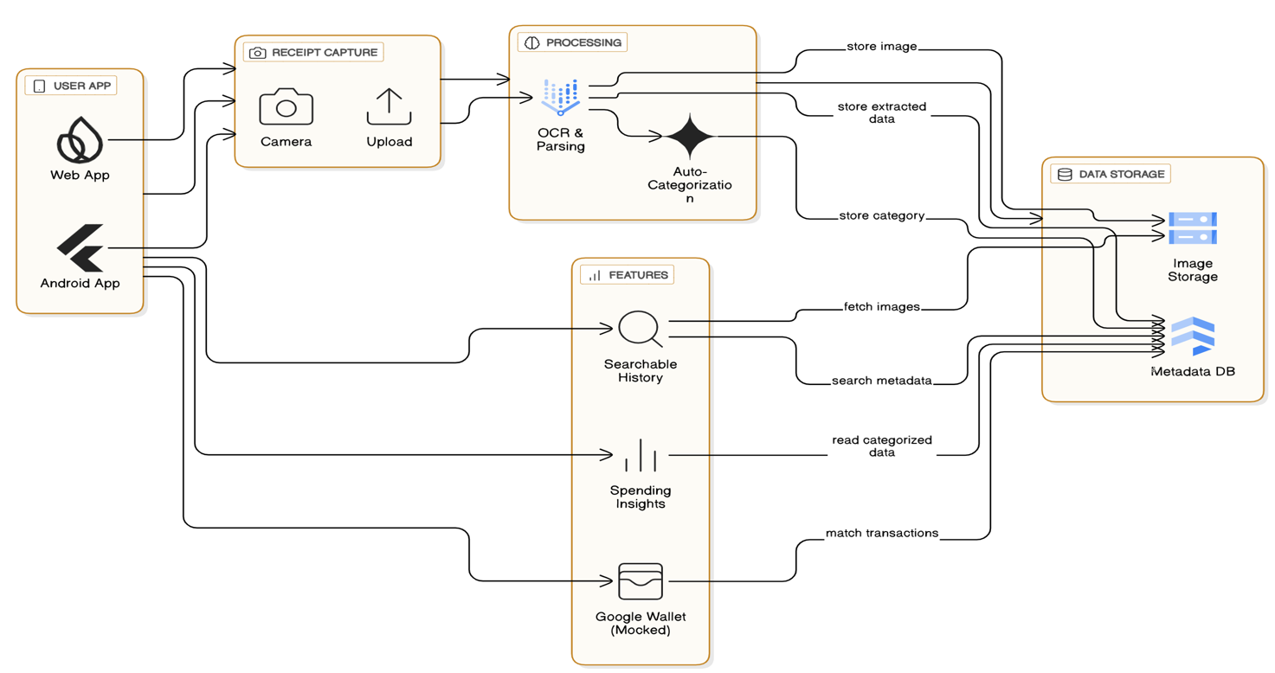

REFERENCES

- Google Cloud Vision Documentation. “Understanding OCR and how text is extracted from images.” Retrieved January 2026, from https://cloud.google.com/vision/docs/ocr
- Firebase Documentation. “Basic setup for authentication, Firestore database and storage.” Retrieved January 2026, from https://firebase.google.com/docs
- IBM Cloud Blog. “Digital document storage and why cloud storage is becoming important.” Retrieved January 2026, from https://www.ibm.com/cloud/blog
- Deloitte Insights. “Digital receipts and how companies are moving toward paperless financial systems.” Retrieved January 2026, from https://www2.deloitte.com/insights

